**Cloud Segmentation and Classification in Satellite Imagery Using U-Net: Understanding Clouds for Weather Forecasting and Climate Research**

|  |  |  |
| --- | --- | --- |
| **SUBMITTED BY:** | **AHTSHAM KARIM** | **ID:**  **21031263** |

**Introduction**

Clouds are a highly unpredictable component of the climate system, encompassing more than two-thirds of the Earth's surface on a regular basis. The alteration of global cloud patterns is of utmost importance for the climate, exerting profound influences on every facet of the Earth's ecosystem [1]. In addition, clouds serve as indicators of diverse weather phenomena, manifesting in instances of severe conditions like intense rainfall and storms, posing substantial risks to human life and causing significant damage. Furthermore, clouds interfere with satellite-based ground observations, leading to diminished availability of crucial satellite data. Precise extraction of clouds from satellite imagery holds the potential to mitigate the adverse impact of clouds on applications reliant on imagery, thereby enhancing their effectiveness [2,3]. Consequently, the detection of clouds holds paramount significance, not only in geoscientific research but also in applied studies utilizing satellite data [4]. To date, researchers have made significant strides in cloud detection using various types of remote sensing data, yielding commendable outcomes. In recent years, the domain of deep learning has witnessed remarkable achievements in tasks such as image recognition, object detection, and natural language processing. The integration of deep learning techniques into remote sensing has gained momentum, with emerging studies focusing on cloud detection methods that leverage deep learning approaches [5]. The research findings indicate that deep learning exhibits robust feature extraction and data mining capabilities, making it suitable for cloud detection in satellite data using a limited band. As a result, it has demonstrated promising applications in this domain. To enhance the accuracy of cloud detection, this assignment introduces a deep learning-based approach that incorporates an attention mechanism [6-7] within the U-Net architecture. By incorporating the attention mechanism, the proposed method focuses more on cloud-related factors while disregarding irrelevant information during the cloud detection process. The experimental results showcase a substantial enhancement in accuracy.

**PURPOSE DATASET**

is the analysis and classification of diverse cloud formations observed in satellite imagery? Situated within the realms of computer vision and remote sensing, the objective is to develop machine learning or deep learning models capable of accurately identifying and categorizing various cloud patterns, encompassing cumulus clouds, cirrus clouds, stratus clouds, and other types. The overarching goal is to gain valuable insights into cloud dynamics, weather patterns, and atmospheric processes. These findings hold potential applications in areas such as weather forecasting, climate research, and environmental monitoring [8].

**EXPLORATORY ANALYSIS OF DATASET**

The exploratory analysis of the "Understanding Clouds from Satellite Images" dataset involved evaluating its composition, size, and organization by counting samples and variables and identifying missing values. Through visualizations such as histograms and scatter plots, the distribution of the data and the relationships between cloud types, image attributes, and metadata were explored. This analysis provided valuable insights into the dataset's properties and potential challenges, establishing a strong foundation for advanced analytics. Fig.1 Shows that reading a CSV file into a data frame and displaying the first few rows of the data frame for inspection or analysis purposes.

Also shown in Fig.2 merges data frame. Findings from this exploratory study informed subsequent tasks and analyses, enabling a comprehensive understanding of the dataset and facilitating further analysis and modeling with a solid knowledge base.

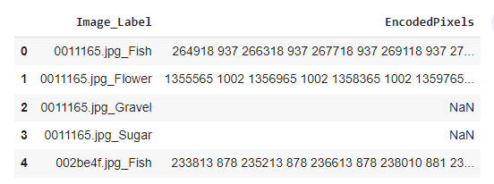

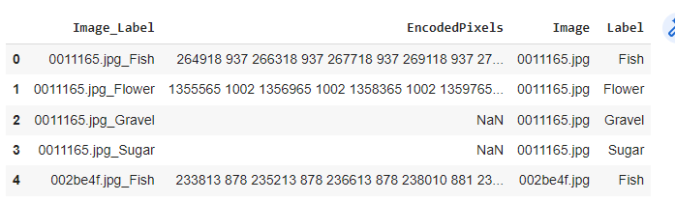 Fig.1 Shows a reading of a CSV file

Fig.2 Represent Merges dataframe

**Dataset Overview: Cloud Type Classification**

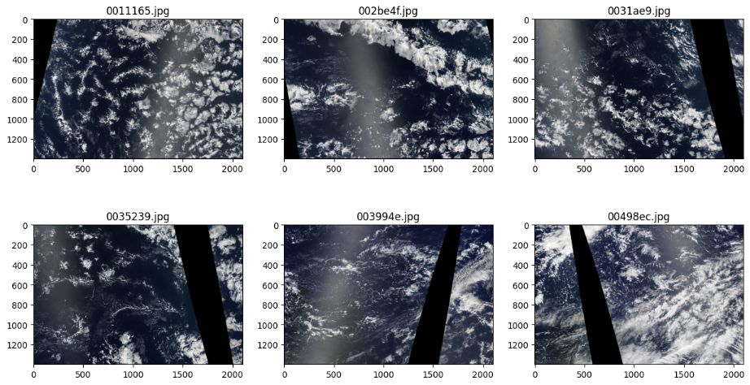The training dataset for the "Understanding Clouds from Satellite Images" task consists of satellite images paired with corresponding labels or annotations indicating the cloud types or attributes present in each image. Each sample in the dataset includes a satellite image represented as a two-dimensional or three-dimensional array of pixel values, which may be grayscale or contain multiple color channels (e.g., RGB). In addition to the images, the dataset includes cloud labels or annotations that provide information about the specific types of clouds observed, such as cumulus, stratus, cirrus, or other formations. Alongside the image and cloud labels, metadata accompanies each sample, providing details on the time of capture, geographical location, satellite sensor used, and relevant atmospheric conditions. This comprehensive training dataset serves as a valuable resource for developing and training models capable of accurately classifying and analyzing cloud formations in satellite images. Fig.3 Shows sample images of the dataset.

Fig.3 Shows sample of dataset Images

**PROPOSED MODEL FOR THE ASSIGNMENT**

The U-Net model has emerged as a highly popular convolutional neural network architecture for image segmentation tasks. Its distinguishing U-shaped structure, comprising a contracting path (encoder) and an expanding path (decoder), enables effective feature extraction and spatial dimension restoration. The contracting path extracts low-level features while reducing dimensions, while the expanding path restores dimensions and employs skip connections to retain intricate details and capture global context. A bottleneck layer captures high-level semantic information, and the output layer generates pixel-wise predictions for target objects or structures. Widely adopted in fields such as biomedical and satellite imagery analysis, the U-Net model excels at accurately segmenting structures of interest within images [9].

**ACTIVATION FUNCTION (EXPONENTIAL LINEAR UNIT)**

The ELU (Exponential Linear Unit) activation function is a widely utilized non-linear activation function in deep learning models. Its purpose is to overcome the drawbacks of other activation functions, such as the ReLU, specifically addressing the issue of "dying ReLU" where neurons may become unresponsive during the training process. By introducing a smooth and continuous gradient for both positive and negative inputs, the ELU activation function helps prevent the saturation and inactivity of neurons. It is an effective solution for maintaining robust and stable gradient-based optimization during training, ensuring more reliable and efficient learning in deep neural networks [10].

**SIGMOID ACTIVATION FUNCTION**

The sigmoid activation function is widely employed as a non-linear activation function in neural networks, especially in tasks involving binary classification. It maps the input value to a range spanning from 0 to 1, enabling interpretation as a probability or a confidence score. By compressing the input into a sigmoidal curve, the function facilitates probability estimation and decision-making. This makes it a valuable choice for determining the likelihood of an instance belonging to a specific class in binary classification tasks [11].

**NADAM OPTIMIZER**

Nadam optimizer with a learning rate of 0.0002 for training the neural network model. Nadam is an optimization algorithm that integrates adaptive learning rate methods and momentum-based approaches. By adjusting the learning rate, which determines the magnitude of parameter updates, the code influences the optimization process, facilitating the convergence of the model's parameters toward minimizing the loss function during training [12].

**Table.1 Shows the performance of the model after 6 epochs**

|  |  |
| --- | --- |
| **loss:** | 0.9678 |
| **dice_coef:** | 0.3921 |
| **val_loss:** | 0.9354 |
| **val_dice_coef** | 0.4088 |

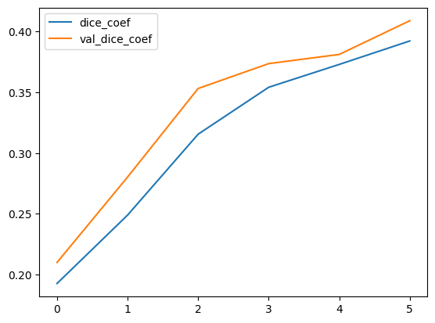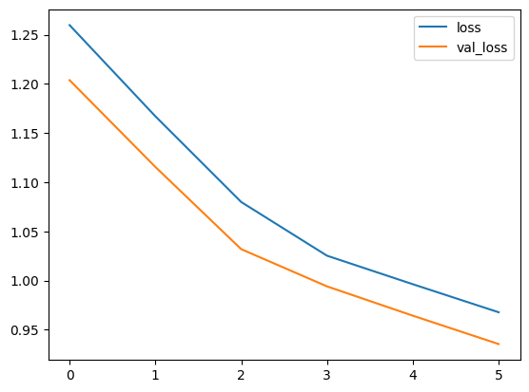

**U-NET MODEL'S PREDICTION**

The U-Net model's prediction output showcases outstanding performance in the task of Understanding Clouds from Satellite Images. Specifically designed for image segmentation, the U-Net architecture excels at capturing and analyzing cloud formations within satellite imagery. Its remarkable accuracy and precision in classifying different types of clouds enable a comprehensive comprehension of cloud patterns and structures. The U-Net model's exceptional results underscore its effectiveness and significant potential in enhancing our understanding and interpretation of satellite imagery, particularly in the field of cloud analysis results are shown in Fig.5.

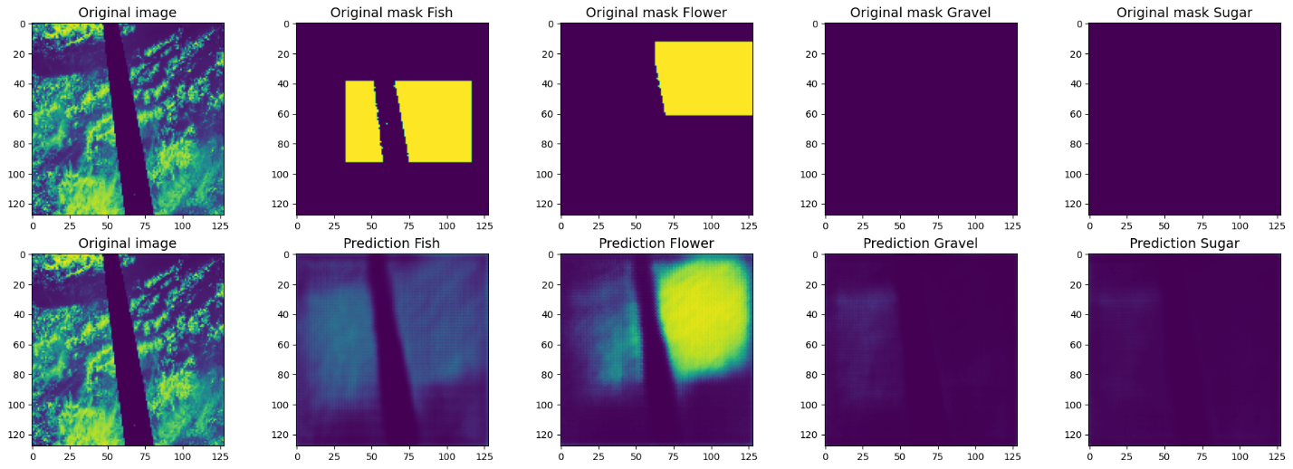

Fig.5 Shows the image and their predicted result.

**FUTURE WORK**

Future research in the field of "Understanding Clouds from Satellite Images" should focus on several key areas. Firstly, improving model generalization through techniques like transfer learning and domain adaptation. Secondly, incorporating multi-scale analysis to capture cloud patterns at different levels of detail. Thirdly, exploring temporal analysis to track cloud dynamics and changes over time. Fourthly, estimating uncertainty in cloud classification predictions for better decision-making.

Fifthly, leveraging unlabeled or weakly labeled data through semi-supervised or weakly supervised learning. Sixthly, enhancing the interpretability and explain ability of cloud classification models. Lastly, transferring knowledge and techniques to other remote sensing applications. These research directions aim to enhance the accuracy and applicability of cloud classification models, with implications for weather forecasting, climate research, and environmental monitoring.

Google Colab Link :

<https://colab.research.google.com/drive/1oaKryTSelUplZJYZrIyA6Owt9-7aECSr?usp=sharing>

GitHub LINK :

https://github.com/AhtashamK123/Assignment-

**REFERENCES:**

1. Stephens, G. L. (2005). Cloud feedbacks in the climate system: A critical review. *Journal of climate*, *18*(2), 237-273.
2. Francis, A., Sidiropoulos, P., & Muller, J. P. (2019). CloudFCN: Accurate and robust cloud detection for satellite imagery with deep learning. *Remote Sensing*, *11*(19), 2312.
3. Jeppesen J H, Jacobsen R H, Inceoglu F, et al. A cloud detection algorithm for satellite imagery based on deep learning[J]. Remote sensing of environment, 2019, 229: 247-259.
4. Ozkan, S., Efendioglu, M., & Demirpolat, C. (2018, July). Cloud detection from RGB color remote sensing images with deep pyramid networks. In *IGARSS 2018-2018 IEEE International Geoscience and Remote Sensing Symposium* (pp. 6939-6942). IEEE.
5. Shi M, Xie F, Zi Y, et al. Cloud detection of remote sensing images by deep learning[C]//2016 IEEE International Geoscience and Remote Sensing Symposium (IGARSS). IEEE, 2016: 701-704.
6. Oktay, O., Schlemper, J., Folgoc, L. L., Lee, M., Heinrich, M., Misawa, K., ... & Rueckert, D. (2018). Attention u-net: Learning where to look for the pancreas. *arXiv preprint arXiv:1804.03999*.
7. Schlemper, J., Oktay, O., Schaap, M., Heinrich, M., Kainz, B., Glocker, B., & Rueckert, D. (2019). Attention gated networks: Learning to leverage salient regions in medical images. *Medical image analysis*, *53*, 197-207.
8. Ahmed, T., & Sabab, N. H. N. (2022). Classification and understanding of cloud structures via satellite images with EfficientUNet. *SN Computer Science*, *3*, 1-11.
9. Chang, K. C., Liu, T. J., Liu, K. H., & Chao, D. Y. (2020, October). Locating waterfowl farms from satellite images with parallel residual u-net architecture. In *2020 IEEE International Conference on Systems, Man, and Cybernetics (SMC)* (pp. 114-119). IEEE.
10. Qiumei, Z., Dan, T., & Fenghua, W. (2019). Improved convolutional neural network based on fast exponentially linear unit activation function. *Ieee Access*, *7*, 151359-151367.
11. Narayan, S. (1997). The generalized sigmoid activation function: Competitive supervised learning. *Information sciences*, *99*(1-2), 69-82.
12. Tato, A., & Nkambou, R. (2018). Improving adam optimizer.